

The vi editor opens. The cursor defaults itself to the first line. Type ‘I’ and press enter. The vi editor now is in INSERT mode as seen below

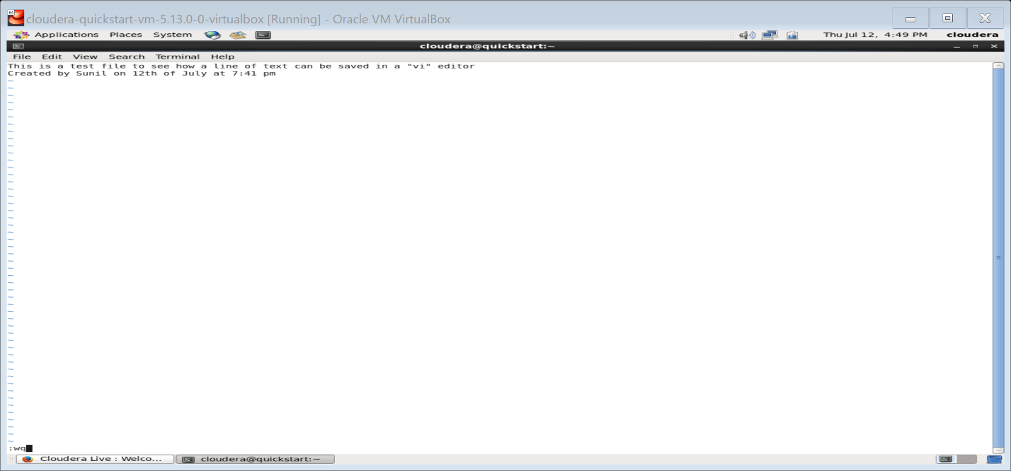

Now type some text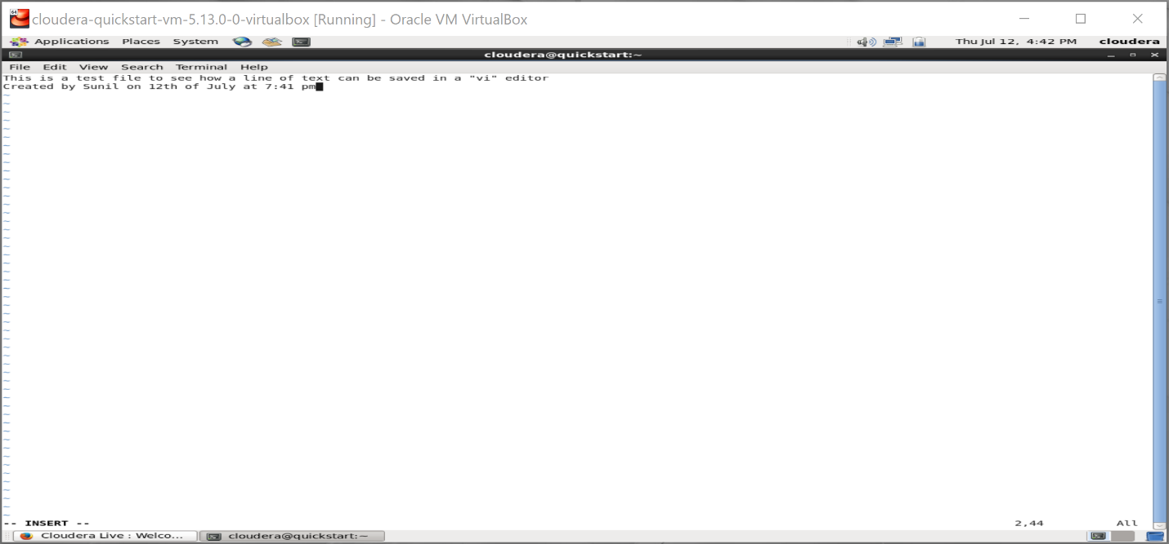

To Save this test file, perform the following steps

1. Press Esc

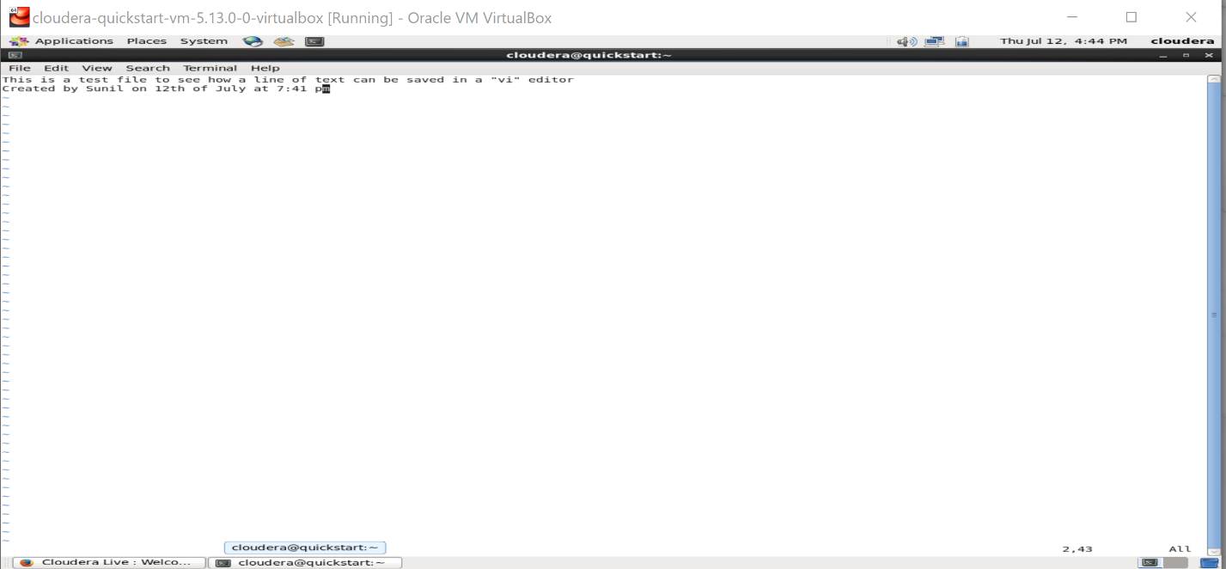

1. Type ‘:wq’

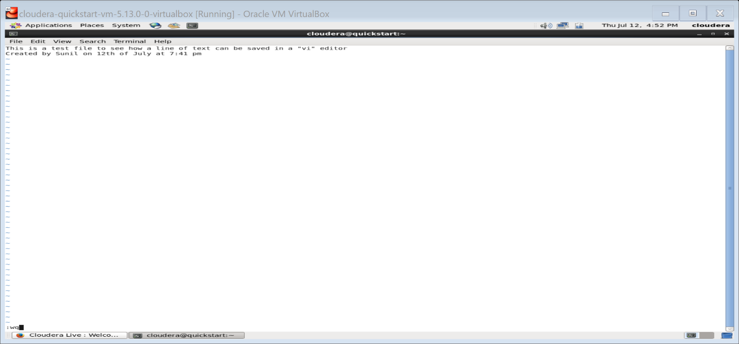

1. Hit Enter and it saves the document and exits the vi editor.

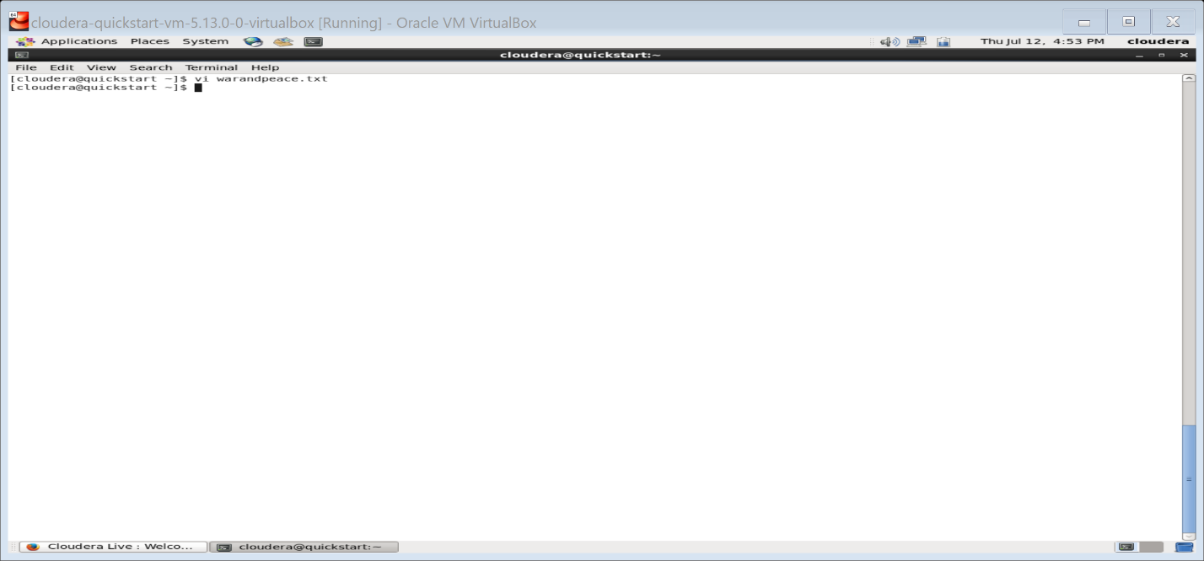

To view this document again type ls. The document would have been saved in the same folder as your prompt was.

